MANONMANI MURUGAN

[Email address]

Abstract

EPS- Functional Document and Roles involved in the tool.

EPS Functional Document

**Table of Contents Page No**

|  |
| --- |
| Global Setup  New Project……………………………………………………………………………………………………………….........2  Global admins Management………………………………………………………………………………………………...2  System notification…………………………………………………………………………………………………………….2  Setup  Discipline………………………………………………………………………………………………………………………….2  Access Management……………………………………………………………………………………………………………2  Module/ Areas…………………………………………………………………………………………………………………….2  Decks/Elevations…………………………………………………………………………………………………………………2  Document List…………………………………………………………………………………………………………………….2  Project Entités…………………………………………………………………………………………………………………….2  Project Information………………………………………………………………………………………………………………2  Project units……………………………………………………………………………………………………………………….2  Item list…………………………………………………………………………………………………………………………….2  Free Criteria………………………………………………………………………………………………………………………2  Data Queries…………………………………………………………………………………………………………………….2  Pre-Commissioning…………………………………………………………………………………………………………….2  Reporting  Excel………………………………………………………………………………………………………………………………2  Power BI………………………………………………………………………………………………………………………….2  AM&T  AM&T Actions………………………………………………………………………………………………………………….3  Tagging………………………………………………………………………………………………………………………….3  General setup…………………………………………………………………………………………………………………4  Family Type Setup……………………………………………………………………………………………………………4  Meet!................................................................................................................................................5  E2S  E2S List………………………………………………………………………………………………………………………….6  Default signatories……………………………………………………………………………………………………………6  Workflow configuration…………………………………………………………………………………………………………………6  Template setup……………………………………………………………………………………………………………….6  Form setup…………………………………………………………………………………………………………………….6  3DR  3DR List………………………………………………………………………………………………………………………10  Default signatories………………………………………………………………………………………………………….11  3DR setup……………………………………………………………………………………………………………………….11  3DR Tagging…………………………………………………………………………………………………………………….11  Form setup……………………………………………………………………………………………………………………...11  Template setup………………………………………………………………………………………………………………...11  ASK  Queries List……………………………………………………………………………………………………………………..14  Tagging……………………………………………………………………………………………………………………………15  Queries Definition……………………………………………………………………………………………………………..15  Default signatories…………………………………………………………………………………………………………….15  Template setup…………………………………………………………………………………………………………………15  Form setup………………………………………………………………………………………………………………………15  General setup…………………………………………………………………………………………………………………..15  ICOD  ICOD List…………………………………………………………………………………………………………………………16  Tagging……………………………………………………………………………………………………………………………16  Origin>Phase>Causes………………………………………………………………………………………………………..16  Distributions……………………………………………………………………………………………………………………..16  Default signatories………………………………………………………………………………………………………………16  General setup…………………………………………………………………………………………………………………….16  Accepting setup………………………………………………………………………………………………………………….16  Administration logs……………………………………………………………………………….19  I -solvelink…………………………………………………………………………………………..20  Help…………………………………………………………………………………………………..20 |
|  |
|  |

**Global Setup:**

Global admin can only view this icon. If the user is a global admin, they can make any user global admin by providing access in Global admins Management. They can also remove other global admin access. The global admin can create new projects in EPS via New project tab. Global can also provide system notification using the tab “System notifications.”

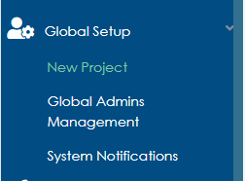

**Setup:**

Global Admin ,Project admin and Super admin can view these icon.They can also setup all the fields such as Discipline,Module/Areas,Deck/Elevations,Document list Project entities,Project information,Project uints,Itemlists,Free criteria and Data Queries .They can also provide access to other users in the project using Access Management field.

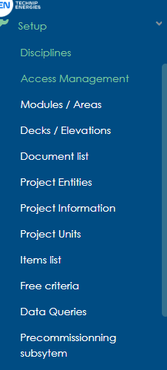

**Reporting**:

All the Admis and T. EN users have access to the Excel report and Power BI report in EPS.

**AM&T:**  
 Action Management & Tracking tool allows to address various actions and other important needs to start, follow and expedite all type of actions during the Project lifecycle to support on decision making, allowing to replace Word/Excel files which are usually created and maintained for that purpose based on the user access to the Entity and Disciplines.

Roles:

**Global Admin**:  
 Global Admin have all rites in the tool to access the data of all project’s entities and disciplines.

* They can view and edit all entity and discipline actions.
* They can also create or Add using the Add button in the user interface.
* They can also create actions using Excel Template.
* They can also export all actions using Excel template.
* They can view and edit the AM&T Module Menu.
* They can change the Tagging pattern.
* They can modify the General setup.
* They can add, edit and delete the Family type. To delete the family type, it must not be mapped to any action.
* They also can create MOM Meet in AM&T.

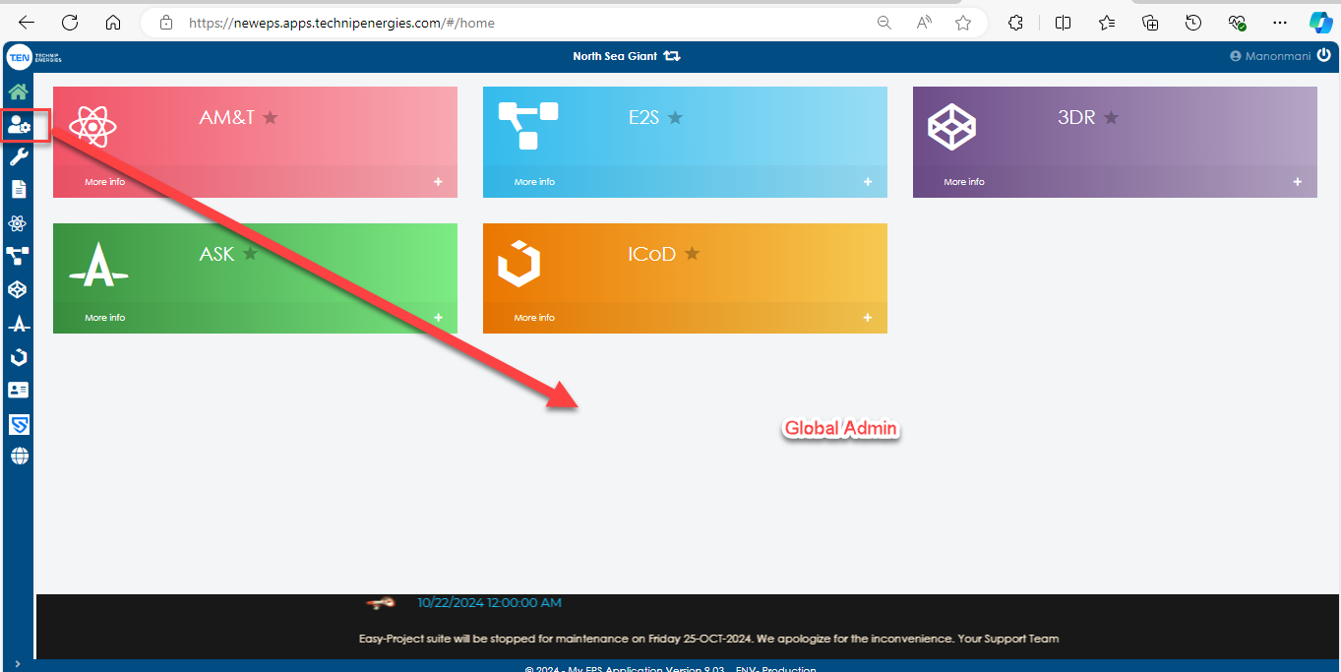

**Super Admin**:  
 Super Admin have access to all entities and discipline in the module and can edit the data in the User Interface. They can view and edit all modules.

***Note: Currently super Admin Role is not applicable for AM&T Module.

**Project Admin**:

Project admin can access the data of all entities and disciplines for the project. They also can view all the modules of the project.

* They can view and edit all entity and discipline actions.
* They can also create or Add using the Add button in the user interface.
* They can also create actions using Excel Template.
* They can also export all actions using Excel template.
* They can view and edit the AM&T Module Menu.
* They can change the Tagging pattern.
* They can modify the General setup.
* They can add, edit, and delete the Family type. To delete the family type, it must not be mapped to any action.
* They also can create MOM Meet in AM&T

**Tool Admin**:

Tool Admin can access the data of all entities and disciplines for the Module in the Project (AMT Tool) and have access to the Tool Menu.

* They can view and edit all entity and discipline actions.
* They can also create or Add using the Add button in the user interface.
* They can also create actions using Excel Template.
* They can also export all actions using Excel template.
* They can view and edit the AM&T Module Menu.
* They can change the Tagging pattern.
* They can modify the General setup.
* They can add, edit and delete the Family type. To delete the family type, it must not be mapped to any action.
* They also can create MOM Meet in AM&T

**T.EN. users**:

Ten users can view all the action in the AM&T list. But they can edit only the action for which Entity and Discipline they have edit access. They can also edit the action if they are responsible for the action even if they don’t have access to the entity and discipline.

* They can view and edit Restricted entity and discipline actions.
* They can also create or Add using the Add button in the user interface for the Restricted entity and discipline they have access to.
* They can also create actions using Excel Template for the Restricted entity and discipline they have access to.
* They can also export all actions using Excel template for the Restricted entity and discipline they have access to.
* They also can create MOM Meet in AM&T

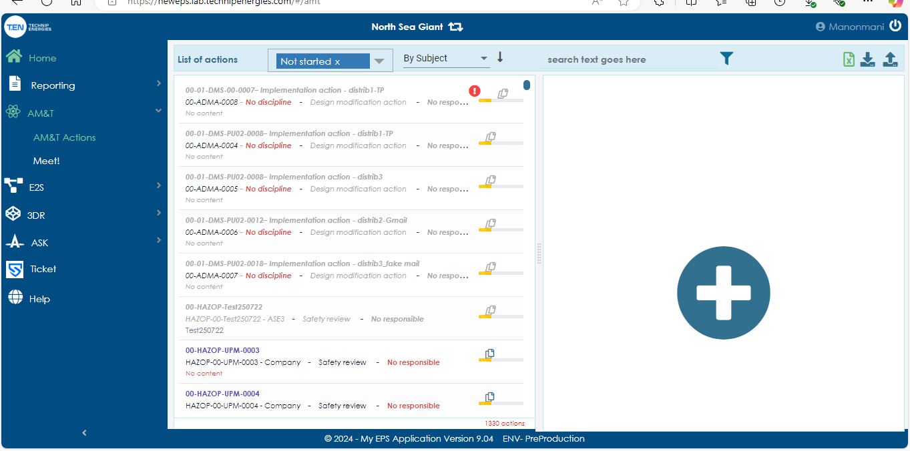

**Partners**:

Partner is also like TEN users. They can view all the action in the AM&T list. But they can edit only the action for which Entity and Discipline they have edit access. They can also edit the action if they are responsible for the action even if they don’t have access to the entity and discipline.

* They can view and edit Restricted entity and discipline actions.
* They can also create or Add using the Add button in the user interface for the Restricted entity and discipline they have access to.
* They can also create actions using Excel Template for the Restricted entity and discipline they have access to.
* They can also export all actions using Excel template for the Restricted entity and discipline they have access to.
* They also can create MOM Meet in AM&T

**Company User**: This user can view and edit only the action for which Entity and discipline they have edit access. If they are responsible for the action even if they don’t have write access to the discipline and entity, they can edit the action.

* They can view and edit Restricted entity and discipline actions.
* They can also create or Add using the Add button in the user interface for the Restricted entity and discipline they have access to.
* They can also create actions using Excel Template for the Restricted entity and discipline they have access to.
* They can also export all actions using Excel template for the Restricted entity and discipline they have access to.
* They also can create MOM Meet in AM&T

**Third Party/ Vendor/ Subcontractor**:  
 Currently these roles are not in AM& T, in future if they have access to this module, they will work like company user in the module.

* They can view and edit Restricted entity and discipline actions.
* They can also create or Add using the Add button in the user interface for the Restricted entity and discipline they have access to.
* They can also create actions using Excel Template for the Restricted entity and discipline they have access to.
* They can also export all actions using Excel template for the Restricted entity and discipline they have access to.
* They also can create MOM Meet in AM&T.

**MOM (Meet):**AM&T Meet is an action created by Admins and Internal user for the actions they create, and they are responsible based on the entity and discipline they have read and write access. Currently it is available for external usersas well.

**E2S**:

Purpose: E2S is a tool to bring a systematic approach to follow and expedite close-out Engineering and HSE reviews on HAZOP, HAZID, ENVID, HRA, etc.…

**Roles:**

**Global Admin, Project Admin, Tool Admin:**

Admins have all the rites in the tool to access the data of all project’s entities and disciplines. They can view and edit all entity and discipline actions in all phases of the E2S.For some projects it starts from Assessing and for some projects it starts from Responding tab.

**

Admin can view the actions created by them in edit mode (Blue color) and created by others in consult mode (Grey color). In assessing phase, they can edit the action pop-up on Action to Perform tab and they can view the Safety review in consult mode.

If the project starts from Responding tab, the admin can edit in Engineering Form and view in Safety review form.

In the Signing-off tab admin can re-assign the current signatory name if necessary.

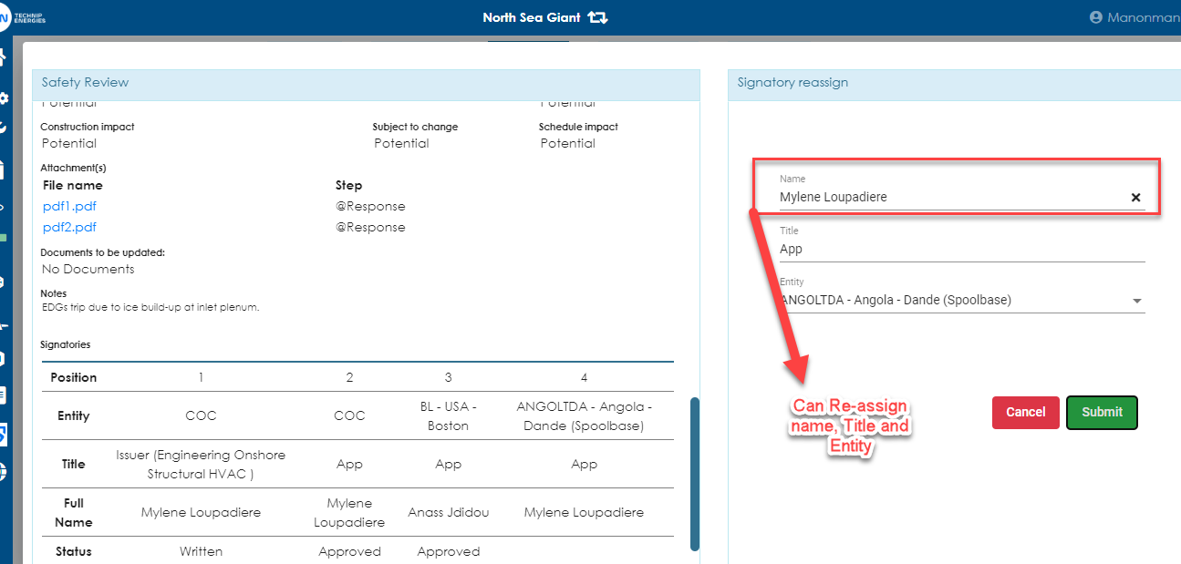

In the Closeout tab global admin can re-open the action. If they re-open the action, the action will move to rejected tab. From there they modify the responses and move to the Signing off tab.

* Admin can upload actions using template and by user interface Add button.
* They can also export each action pdf and bulk pdf exports.
* They can also export My scope list.
* admin can edit and view all the setup Menu in E2S Tool

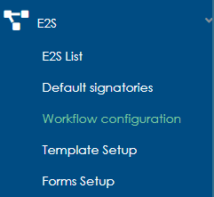

**Super Admin**:

Super admin can have all the rites in the tool as Global Admin apart from that they can also edit the action fields using the button ‘Open to Update’.



When you click this Open to Update button in the Action it will open the action in edit mode in all phases of E2S.

Technip User:

Currently other discipline and Entity action were visible to T.EN users in consult mode (Grey color) in Assessing and Responding tab (If the Project configuration is set as assessing it will appear on this mode).For the entity and discipline which they have write access will appear in edit mode (Blue Color).There is no add button for them in UI . But they can import actions using templates. They can export my scope list it contains all the actions that are visible in the UI screen. They can export the actions via PDF for read and write access actions. They can also export Bulk PDF.

Consult Mode:

Assessing Responding:  
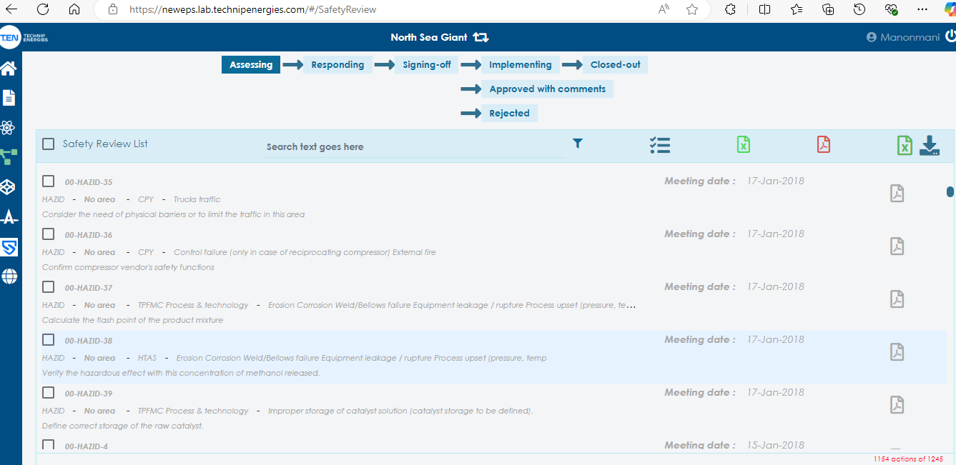

In edit mode action the T. EN user can Proceed in Assessing mode and in Responding tab they can give the response, assign signatories, and submit the actions.

If they are in the signatory loop they can approve or reject the action. If they are the last signatory of the loop they can approve with comments for the actions.

In the Approve with comments tab the actions which were approved by them and have edit access is only visible.

In the Reject tab, other entity and discipline actions appear in consult mode and the actions for which they have write access will appear in edit mode. They can submit the actions for which they have edit access.

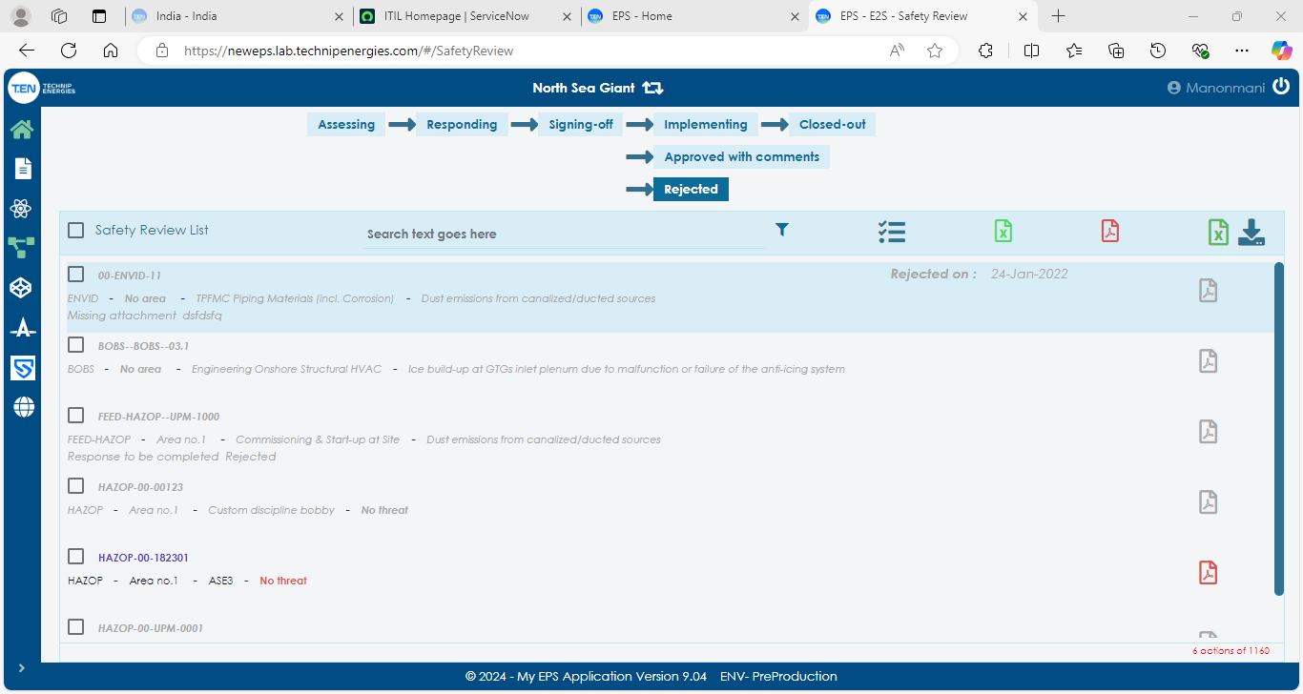

Company Users:

Company users can view only from Responding tab, in the signing of tab if the user is in signatory loop of the action and if they are current signatory it will appear in Edit mode. They can either Approve or Reject the action. If they are last approve of the action they can also approve with comments.

Approve with comments if the company is last approver, in that case if the evidence is submitted for the action in signing off tab again the company user can approve it for that purpose only we have “Position 99”.  
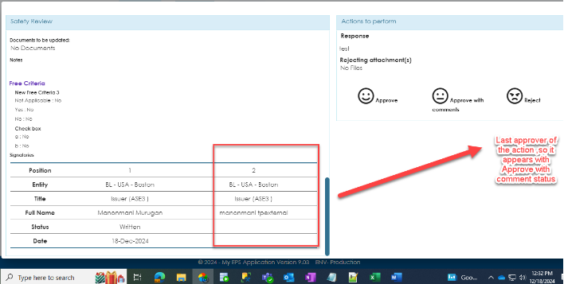 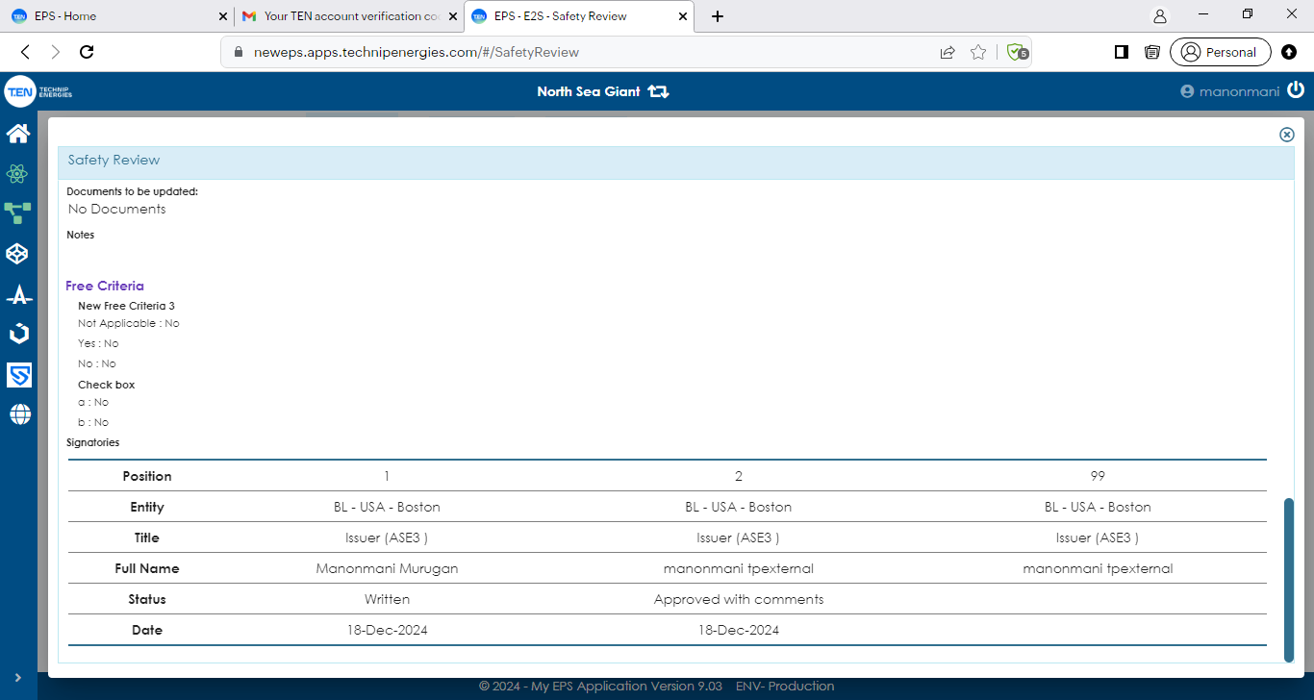

In the rejected tab for the company user actions will appear in consult mode. The compay user can export the actions in PDF for the actions in consult mode and can also export Myscope list.

Currently in EPS there is no vendor ,partner ,subcontractor and Third party is using the EPS .

**3DR:**

**Purpose**: 3DR is the Module dedicated to the management of actions from 3D Model Review.

**Roles:**

**Global Admin, Project Admin, Tool Admin:**

Admins can view all the phases of the 3DR module. Below screenshot provide the phases of the 3DR module.

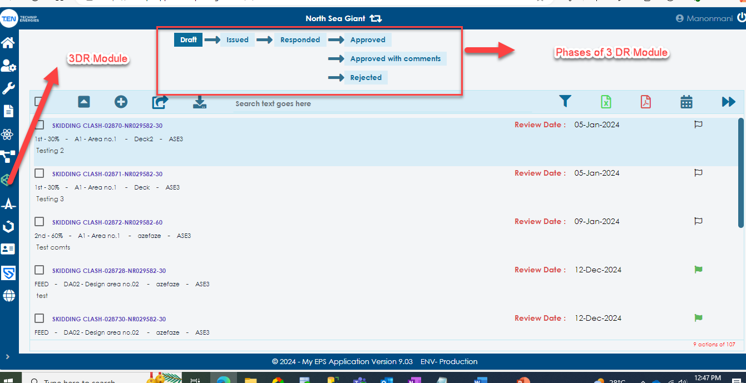

The below screenshot shows the each icon and their functionality in the 3DR module.

Global Admin can only import the 3DR review via Excel template in EPS tools currently, they can also upload the Review snaps for the Tags,

**Global Admin**:  
 Global Admin have all rites in the tool to access the data of all project’s entities and disciplines.

* They can view and edit all entity and discipline Tags.
* They can also create or Add using the Add button in the user interface.
* They can only create actions using Excel Template.
* They can also export all actions using Excel template (My scope list).
* They can view and edit the 3DR Module Menu.
* They can change the Tagging pattern.
* They can modify the 3DR setup, Form set up & Template set up.
* They can add, edit and delete the default signatories.
* They can also export PDF extracts for single Tag and Bulk pdf export is possible.
* They cannot move the rejected tag to again issued tab. Currently it can be done by only the Technical team in the DB level.

Project Admin and tool Admin can also perform the above functions except creating new tag using via Excel template and including snaps in the tag.

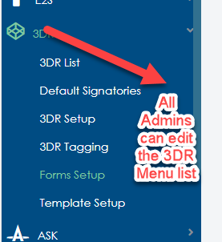

**Super Admin:**

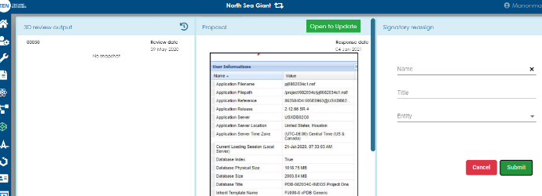Super admin can move the query to previous phase, modify and clear signatories, edit the fields of the Tag except the snap fields using the button ‘Open to Update’.

**T. EN Users:**

Technip users can view the Tags for which entity and discipline they have write access and Read access from Issued tab.

In the responding tab only for which tags they are current signatory will appear in edit mode (Blue color). If the user is Issuer of the tag and other tags of same discipline and entity created by other users will appear in consult mode.

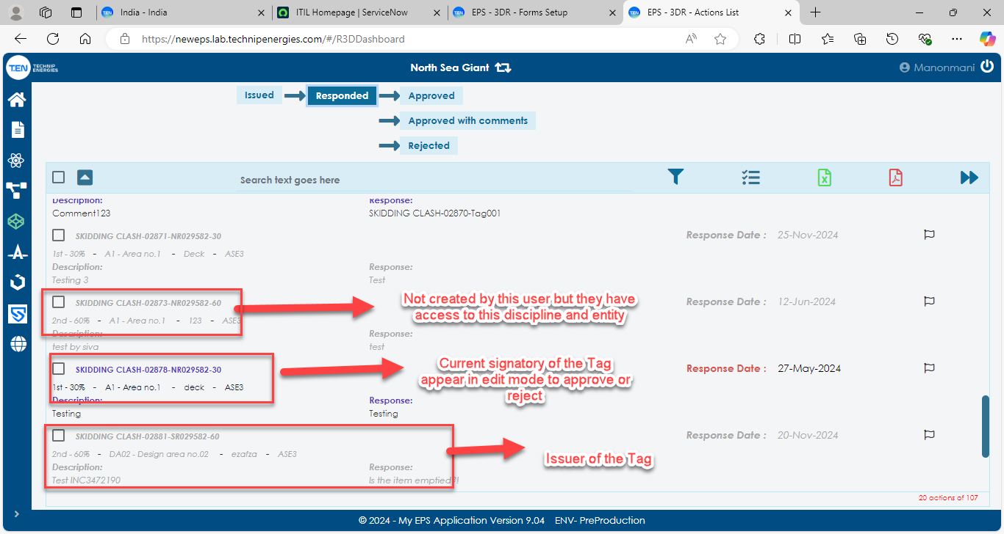

In Approved tab the tags will appear in blue color, but they cannot edit the tags, can export bulk pdf and single pdf for the tags. They also can export my scope list from all tabs. In approve with comments if the user A is not last signatory and if it is created by other user B of the same discipline and entity will appear in consult mode. Rejected tab the tags will appear in consult mode.

Company user:

If the company user is a current signatory will appear in edit mode in response tab as above. If the tag is approved for the company user it will also appear in consult mode.

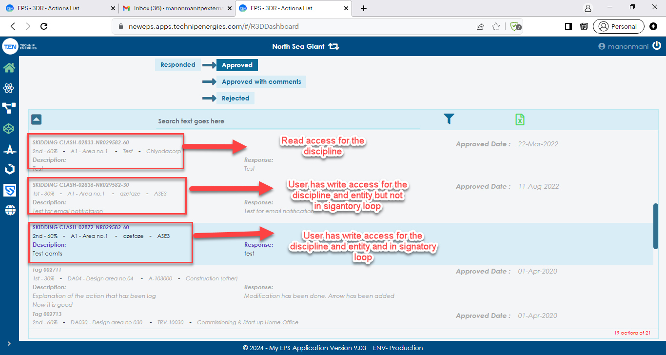

If the company user is last signatory and approved the tags with comments, then for the company user the tag will appear in edit mode to add evidence or to revise the tag.

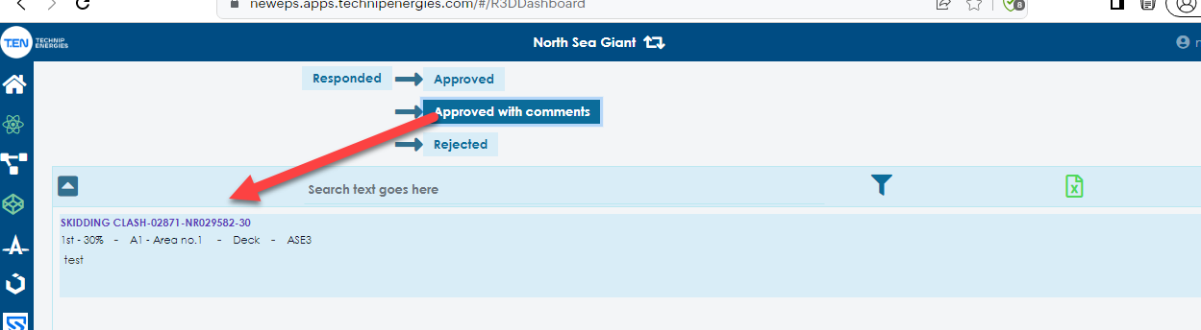

In the Rejected tab for the company user tags will appear in Consult mode though it appears in blue color. Only admins can revise the data from the rejected tab.

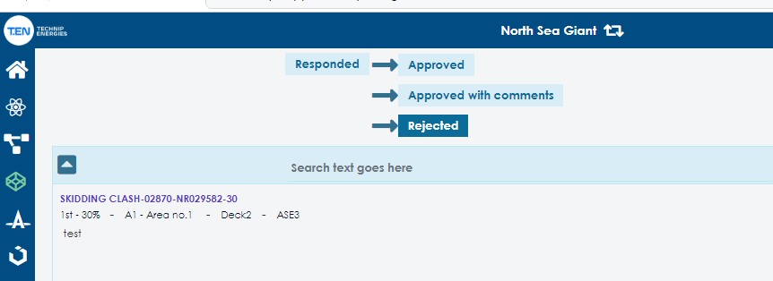

Currently there were no Vendor, subcontractor and Third party using the 3dr module.

**ASK:**  
ASK is a tool to expedite technical queries and deviations between Technip Energies and External Project parties (e.g. Client) since its creation until its closure. Facilitate communication between all Project members acting in the validation chain for the query closure.

**Global Admin, Project Admin, Tool Admin:**

Admins have all the rites in the tool to access the data of all project’s entities and disciplines. They can view and modify the signatories of all entity and discipline query in all phases of the ASK. In the close out and Reject tab they can also revise the query. They can export PDF extracts for single Query and bulk queries using EDMS and GAIA export. My scope list can also be extracted via excel. In drafting phase only, the issuer of the query can view their drafted queries, even admin have the same rites. From Issuing to closing phase the admins can modify the current signatories if necessary. They can also modify the ASK Menu setup like, Tagging, Queries definition, Default signatories, Template setup, Form setup and General Setup.

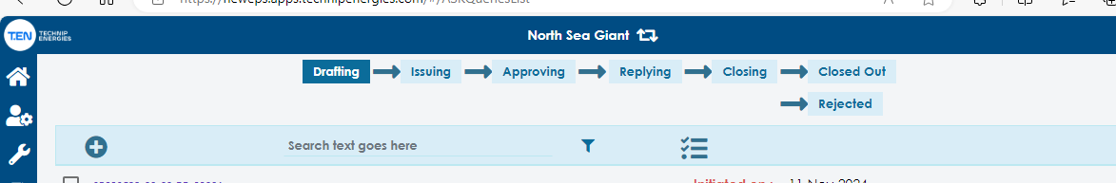

**Super Admin:**

From Issuing to closing the super admin can edit the fields of the query, move to previous phase and can modify & clear the signatories using the button “Open to update.”

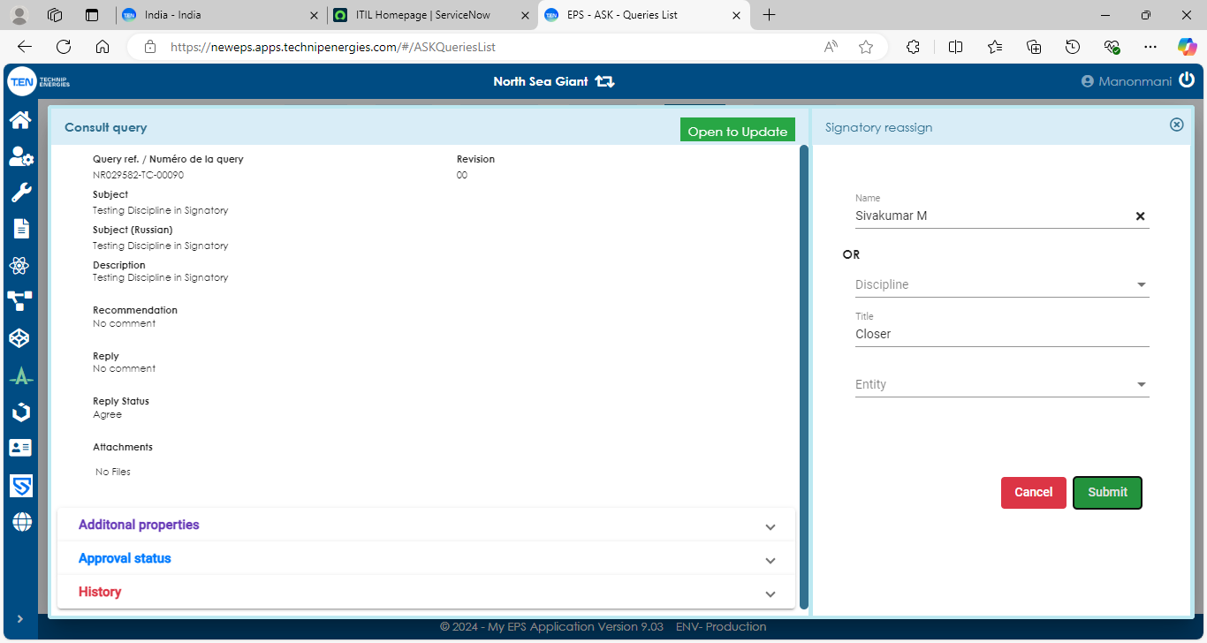 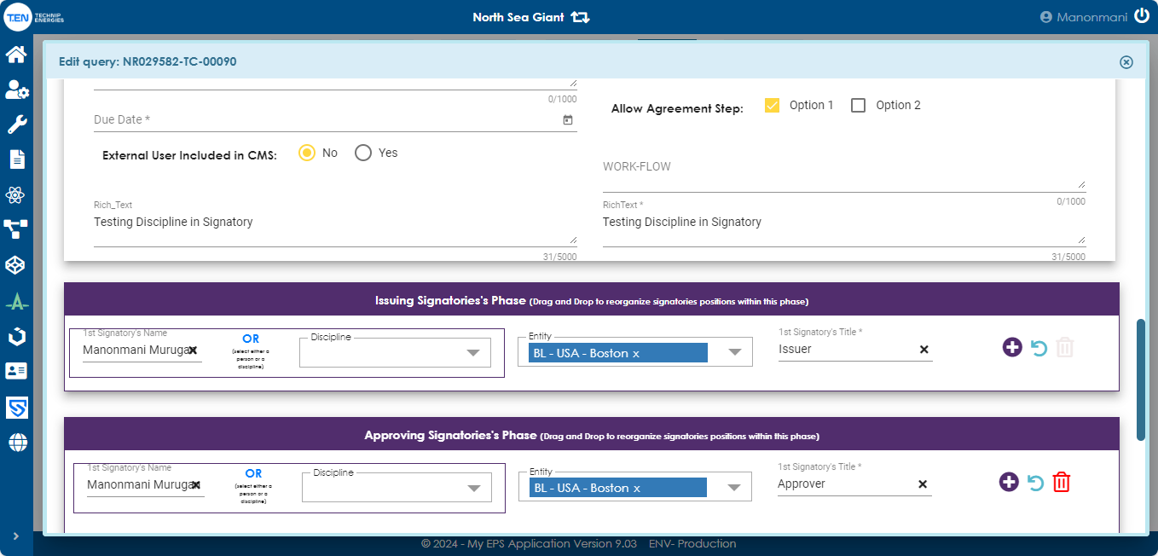

**T.EN Users:**

For which entity and discipline they have write access ,they can create query for that access and view the same in the draft status. Once submitted from draft status, if the issuer of the query is different from the submitter then it will move to “Issuing phase”.If the issuer is same as submitter then it will move to “approving” phase.

* They export a single PDF of the query.
* They can export EDMS & GAIA export of the bulk queries.
* They can export My scope list.
* If they are the current signatory, it will appear in edit mode to approve or reject.
* Currently for the write access discipline & entity query will appear in blue color if they are the approver, for other discipline and entity queries will appear in consult mode (grey color).
* If the TEN user has “Is Document Control” checked in access level, they can export the action to EDMS/GAIA. It was highlighted by the flag in the query.

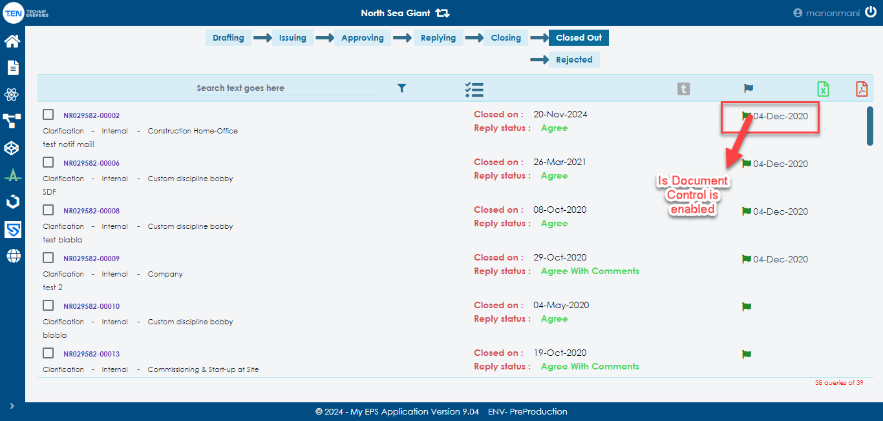

**External User (Company User, Subcontractor, Vendor):**

For all the external users for which entity and discipline they have write access, they can create queries for that entity and discipline in draft phase, they can also approve or reject the query in the approving, replying to status. For other entity and discipline if they have read access, they can view in the consult mode in all phases. They can also export PDF for single query, EDMS/GAIA export and export My scope list.

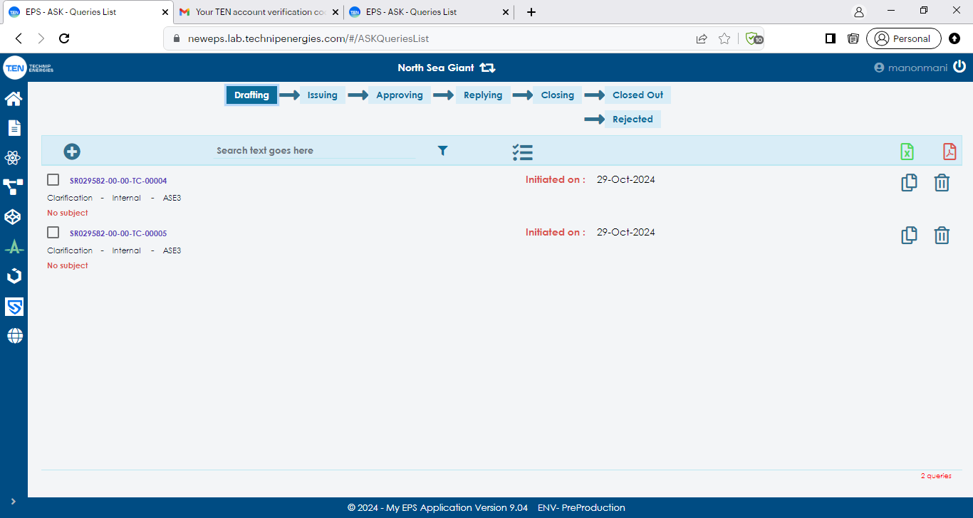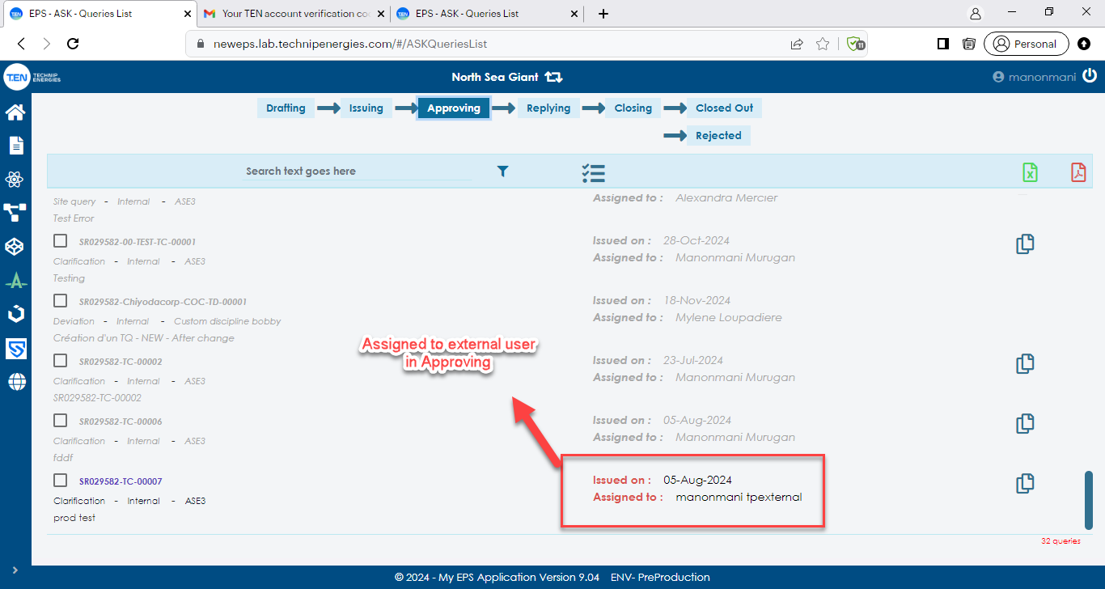

If the query is assigned to the external user discipline also, they can approve or reject in both Approving and Replying status.

Note: In ASK for the Issuing entity the receiving entity is mapped in the general setup. So, if the query entity is mapped only then we can create query.

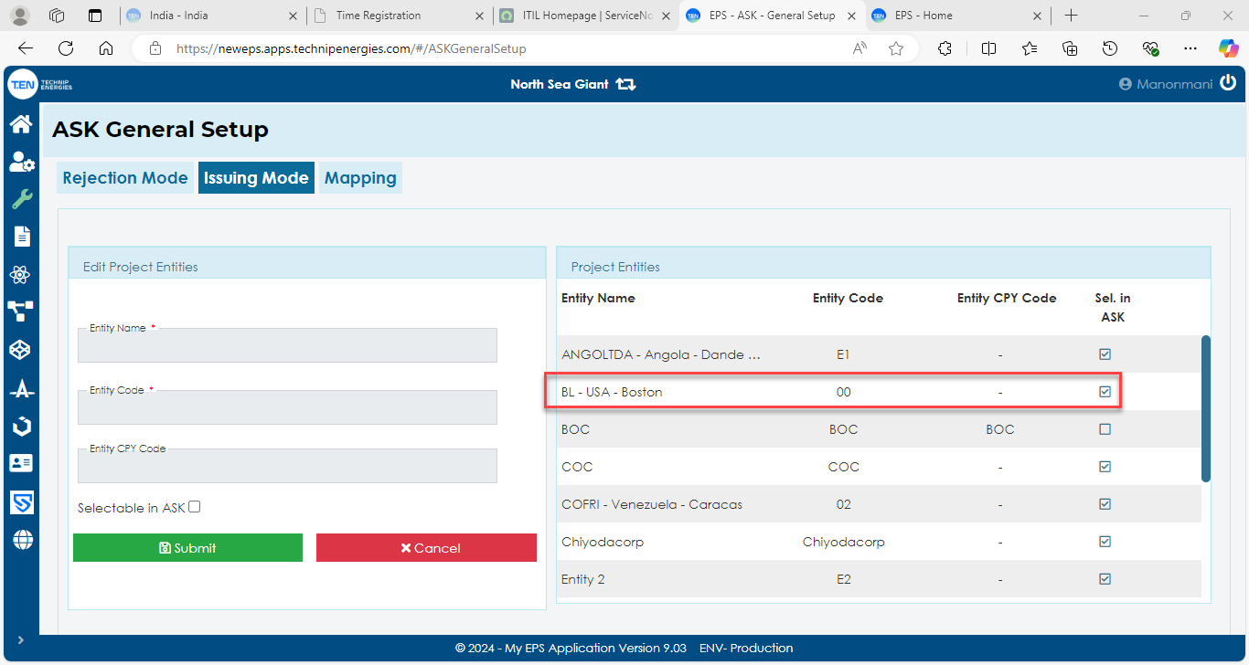

**ICOD:**

ICOD is the EPS module dedicated to all requests for major design change, regardless of source or reason, that may impact upon design, procurement, construction, commissioning or operation related activities**.**

**DMS-Design Modification sheet is used in process level.**

**-** IFC-Issue for construction

- Created by the process team.

-Diffèrent départements.

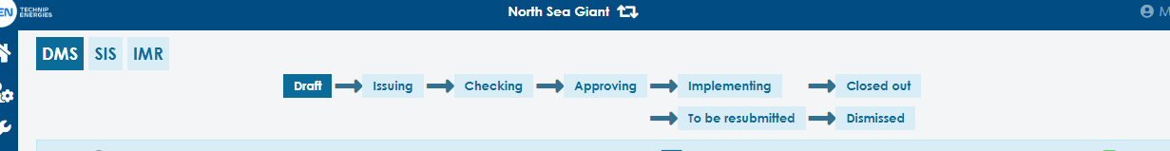

**SIS-Site Instruction Sheets.**

- During construction on site small changes need to be implemented by engineers on site. (from Office to Site).

- Civil and Structural Départements.

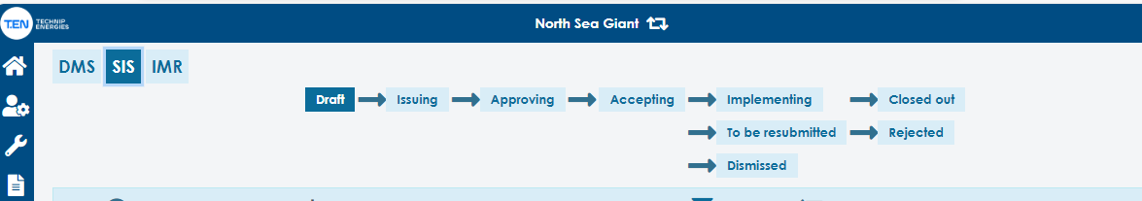

**IMR-Instrumentation Modification Record.**

- Some changes which cannot be implemented in the original site can be sent back to Engineers from (Site to office).

-It occurs after / while construction is in process.

- Testing will be done.

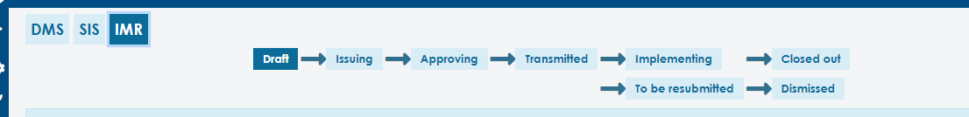

**Global Admin, Project Admin, Tool Admin:**

Admins have all the rites in the tool to access the data of all project’s entities and disciplines. They can view and modify the signatories of all entity and discipline query in all phases of the ICOD. In the close out and Reject tab they can also revise the query. They can export PDF extracts for single Query and bulk queries using EDMS and GAIA export. My scope list can also be extracted via excel. In drafting phase only, the issuer of the query can view their drafted queries, other queries in consulting mode. From Issuing to closing phase the admins can modify the current signatories if necessary. They can also modify the ICOD Menu setup like, Tagging, Distributions, Default signatories, Template setup, Form setup, General Setup and Accepting setup.

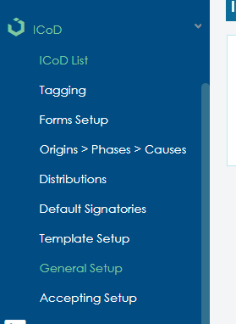

In General setup Impact entity is set only for the IMR Module in ICOD.

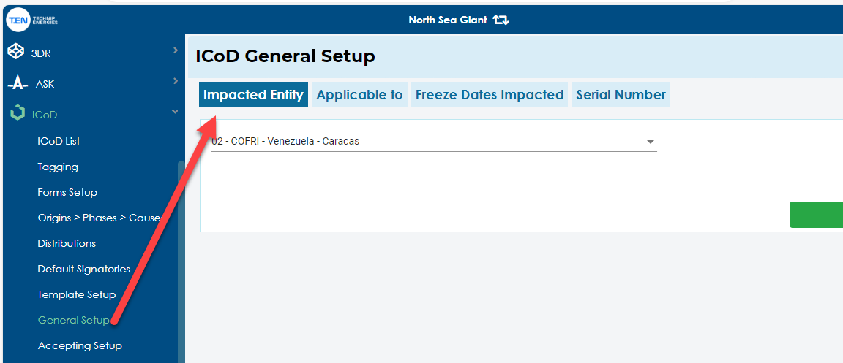

The flow is similar in all DMS/SIS/IMR, the only difference between each module is the Checking in DMS, Accepting in SIS and Transmitted in IMR.

**Checking in DMS:**

Currently in DMS checking is performed by CAD engineers, users who have been checked as CAD Checking in access management can perform the checking in DMS. For these users to which entity and discipline they have access that DMS will appear in EDIT mode in checking, and they can edit the fields, can assign new approver or even can move the DMS to “To be resubmitted” phase.

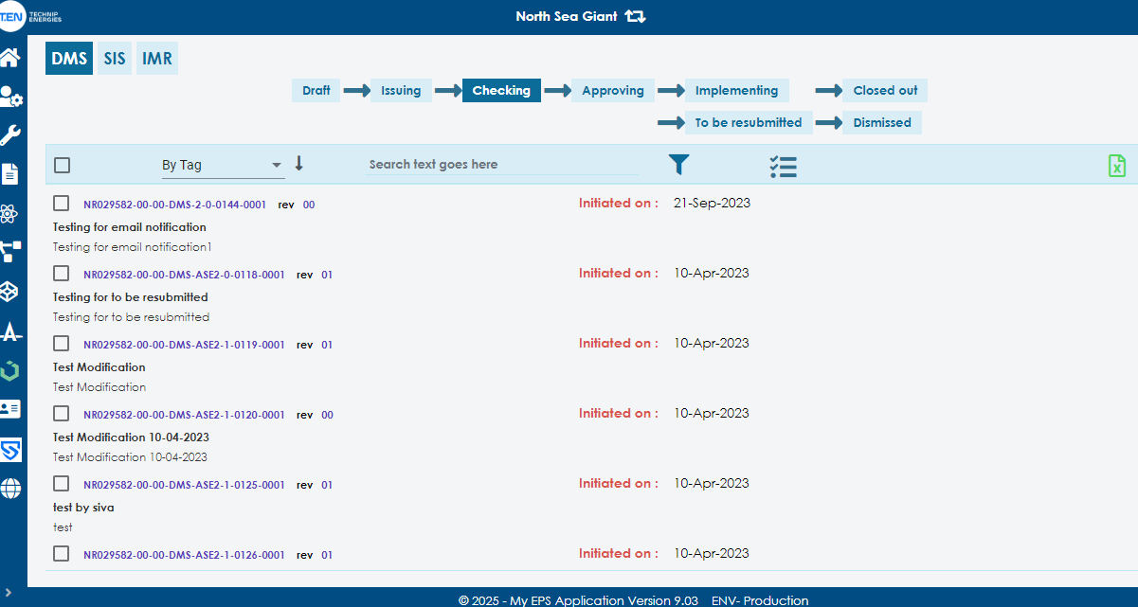

**Accepting in SIS:**

Currently in SIS Accepting is performed by Field Engineers, users who have checked as Field Engineering in access Management can accept the SIS. For these users to which entity and discipline they have access that SIS will accept or move to “To be re-submitted” phase.

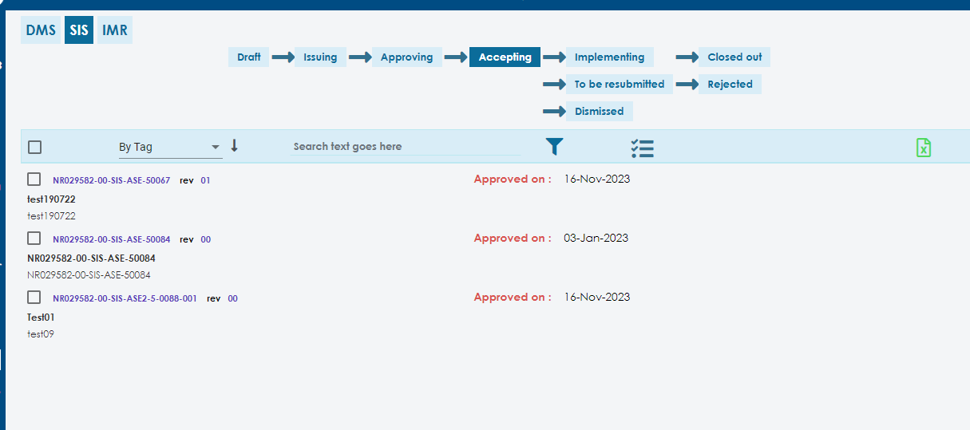

**Transmitted in IMR:**

Currently in IMR Transmitted is performed by ICST, users who have checked as “In ICST” in access Management can transmit the IMR. The Transmitted signatory will not appear in the Approval status. In the transmitted phase they will submit the comments.

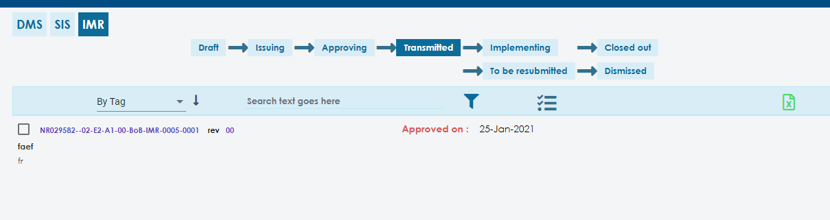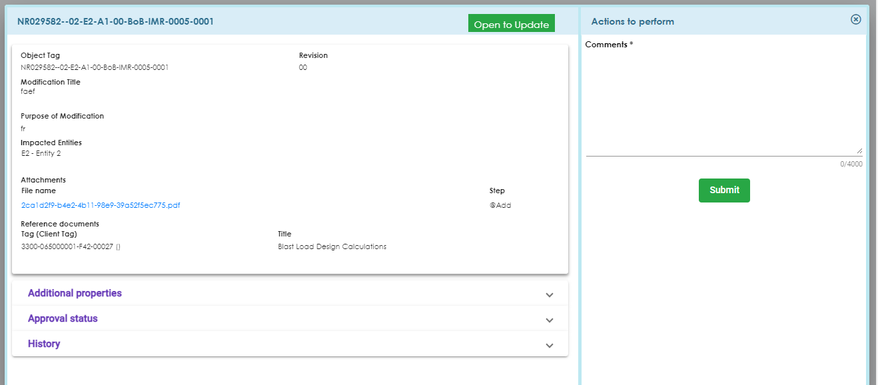

**T.EN Users:**

For which entity and discipline they have write access ,they can create DMS/SIS/IMR for that access and view the same in the draft status. Once submitted from draft status, if the issuer of the query is different from the submitter then it will move to “Issuing phase”.If the issuer is same as submitter then it will move to checking phase for DMS and “approving” phase for SIS and IMR. For the T.EN user if the CAD checking is disabled in Access management ,In checking the DMS will appear in consult mode.Similarly for Field Engineering is disabled in access management the SIS will appear in Consult mode.

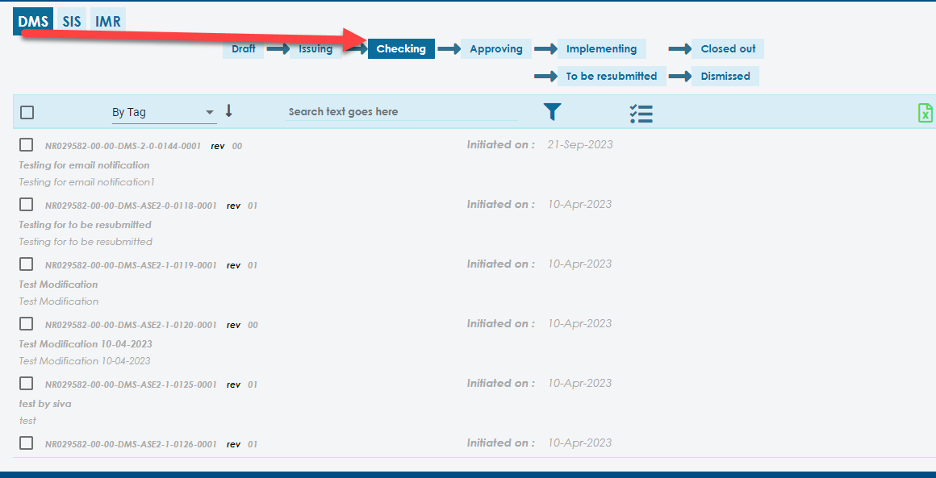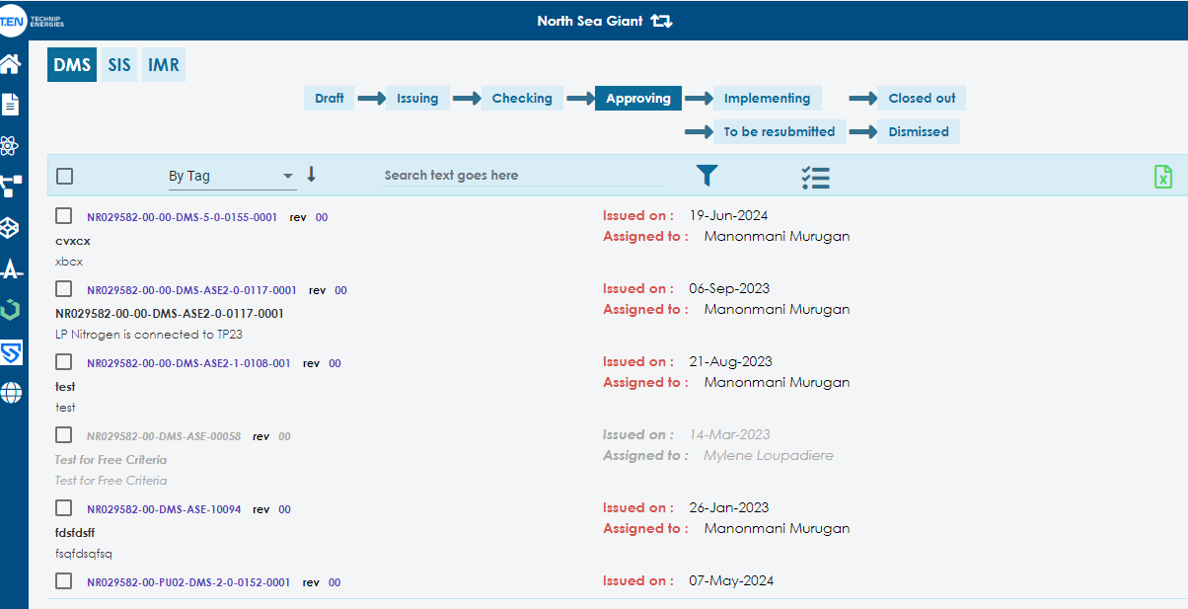

* They export a single PDF of the DMS/SIS/IMR.
* They can export EDMS & GAIA export of the bulk DMS/SIS/IMR.
* They can export My scope list.
* If they are the current signatory, it will appear in edit mode to approve or reject.
* Currently for the write access discipline & entity query will appear in blue color if they are the approver, for other discipline and entity queries will appear in consult mode (grey color).
* If the TEN user has “Is Document Control” checked in access level, they can export the action to EDMS/GAIA. It was highlighted by the flag in the query.

Currently there are no external users using ICOD module.

**Administration logs:**

In super Admin Roles if they edit any filed in any module, that field changes will be highlighted in the logs with old value and new value of the fields.

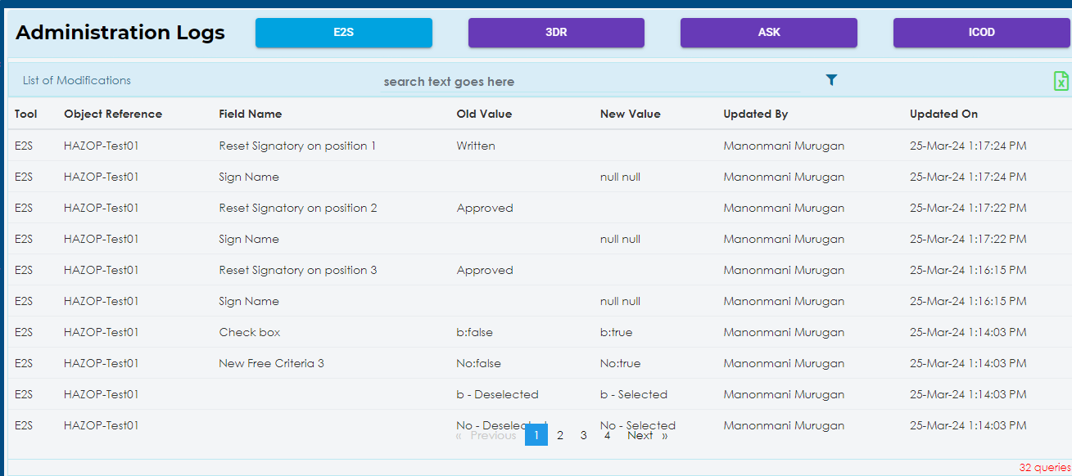

**iSolve Link:**  
It will take to I-solve link:

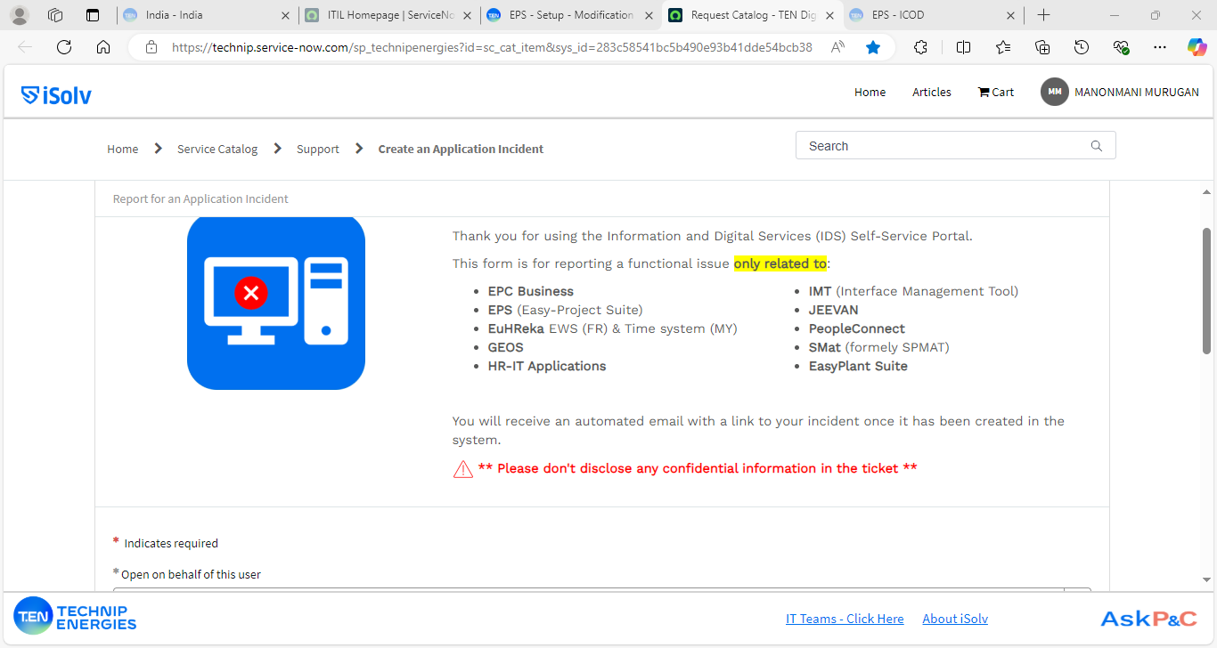

Help:

Share point of the EPS   
